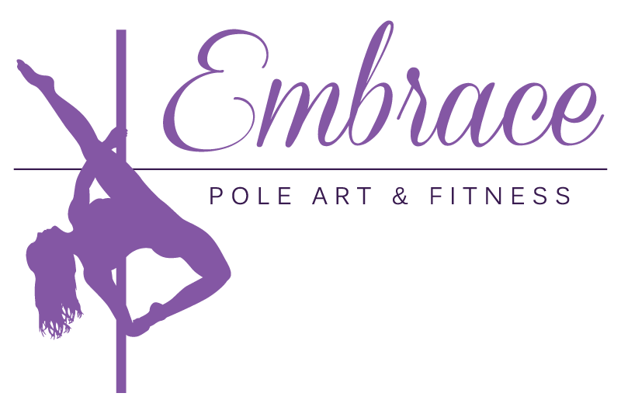

Monday
6:00 – 7:00 pm Level 6/7 Pole Fitness
7:15 – 8:15 pm All Levels Stretch
8:30 – 9:30pm Level 5 Pole Fitness

Tuesday
6:00 – 7:00 pm Level 4 Pole Fitness
7:15 – 8:15 pm Heels Technique
8:30 – 9:30 pm Level 5/6 Pole Fitness

Wednesday
4:45 – 5:45 pm Open Pole Practice
6:00 – 7:00 pm Level 3 Pole Fitness
7:15 – 8:15 pm Level 1 Pole Fitness
8:30 – 9:30 pm Level 2 Pole Fitness

Thursday
5:45 – 6:45 pm Level 6/7 Pole Fitness
7:00 – 8:00 pm Handstands (Nov. 5 & 19)
7:00 – 8:00 pm Polestands (Nov. 12 & 26)
8:15 – 9:15 pm Level 3 Pole Fitness

Drop-In Class / 3 or 4-Week Series

Class Schedule
Nov. 2 – Nov. 29

Friday
6:00 – 7:00 pm Pole Art Choreo (Nov. 6)
6:00 – 7:00 pm Heels Flow (Nov. 13)
6:00 – 7:00 pm Basic Slow Flow (Nov. 20)
7:15 – 8:15 pm Open Pole Practice

Sunday
10:00 – 11:00 am Open Pole Practice
11:15 am – 12:15 pm Level 5 Pole Fitness
12:30 – 1:30 pm Level 4 Pole Fitness
1:45 – 2:45 pm Level 2 Pole Fitness
3:00 – 4:00 pm Level 1 Pole Fitness

Events
Friday, Nov. 27 @ 6:00 pm – Intro to Pole Fitness
Saturday, Nov. 14 @ 11:00 am – Exotic Flowshop with Onyx
Saturday, Nov. 14 @ 12:45 pm – Twerkshop with Onyx

Important Dates
Nov. 11 – Embrace Closed for Remembrance Day

Schedule is subject to change. Please refer to ScheduleHouse for the most up-to-date schedule.

Monday
6:00 – 7:00 pm Level 6/7 Pole Fitness
7:15 – 8:15 pm All Levels Stretch
8:30 – 9:30pm Level 5 Pole Fitness

Tuesday
6:00 – 7:00 pm Level 4 Pole Fitness
7:15 – 8:15 pm Barre
8:30 – 9:30 pm Level 5/6 Pole Fitness

Wednesday
4:45 – 5:45 pm Open Pole Practice
6:00 – 7:00 pm Level 3 Pole Fitness
7:15 – 8:15 pm Level 1 Pole Fitness
8:30 – 9:30 pm Level 2 Pole Fitness

Thursday
5:45 – 6:45 pm Level 6/7 Pole Fitness
7:00 – 8:00 pm Handstands (Dec. 3 & 17)
7:00 – 8:00 pm Polestands (Dec. 10)
8:15 – 9:15 pm Level 3 Pole Fitness

Drop-In Class / 3 or 4-Week Series

Class Schedule
Nov. 30 – Dec. 23

Friday
6:00 – 7:00 pm Basic B**** Twerk (Dec. 4)
6:00 – 7:00 pm Heels Flow (Dec. 11)
6:00 – 7:00 pm Christmas Choreo (Dec. 18)
7:15 – 8:15 pm Open Pole Practice

Sunday
10:00 – 11:00 am Open Pole Practice
11:15 am – 12:15 pm Level 5 Pole Fitness
12:30 – 1:30 pm Level 4 Pole Fitness
1:45 – 2:45 pm Level 2 Pole Fitness
3:00 – 4:00 pm Level 1 Pole Fitness

Important Dates
Dec. 24-27 Embrace Closed for Christmas Break

Schedule is subject to change. Please refer to ScheduleHouse for the most up-to-date schedule.

